WORKING STANDARD OPERATING PROCEDURE
IT Equipment Loan & Return Management System (equipment_loan)
Complete Step-by-Step Operator Guide with Verified UI Screenshots
Document ID | SOP-OPS-ITAM-2026-001
System Module | IT Asset Management (ITAM) • Frappe Framework
Effective Date | September 21, 2026
Target Operators | IT Helpdesk Technicians, Asset Managers, Department Approvers, Employees

1. Purpose & Operational Objectives
This Standard Operating Procedure (SOP) provides a complete, visual, step-by-step operational manual for issuing, tracking, and inspecting corporate IT hardware assets (laptops, displays, cameras, and peripherals) using the IT Equipment Loan System built on Frappe Framework.
[CORE POLICY MANDATE] Zero-Loss Mandate: Every hardware item leaving IT Helpdesk custody must be registered in an Active Equipment Loan document with itemized serial numbers, signed voucher agreement, and scheduled return date not exceeding 30 calendar days.

2. Roles & Responsibilities (RACI Matrix)
Role Title | Key Operational Responsibilities | Frappe Desk Role Binding
IT Asset Administrator | Validates eligibility, issues hardware, submits loan doc, performs return physical check. | IT Asset Manager (Full CRUD + Submit + Cancel)
Employee Borrower | Takes physical custody, signs voucher, returns hardware on or before due date. | Employee (Portal View, E-sign)
Department Manager | Authorizes high-value loans (> $3,000) or extended multi-month loan renewals. | Department Manager (Approver)
Compliance Auditor | Reviews monthly audit trail, verifies overdue borrower lockout, checks loss ratios. | Auditor (Read-Only access to all logs)

3. Step-by-Step Operator Walkthrough
Step 3.1: Navigating to Equipment Loan Form
1. Open Frappe Desk in your browser (https://itam.company.internal).
2. In the Awesomebar (Ctrl + G or ⌘K), type 'Equipment Loan' and select Equipment Loan List.
3. Click '+ Add Equipment Loan' to instantiate a new draft record.
Step 3.2: Assigning Borrower & Validation Rules
1. Select the Borrower Employee (e.g. EMP-00104 - Alex Mercer). The Department auto-populates from the Employee master record.
2. If an employee has active overdue items (e.g. EMP-00105 - Jordan Lee), the system throws an immediate PermissionError and blocks loan creation.
3. Set the Loan Effective Date and Expected Return Date. The period cannot exceed 30 days.
Step 3.3: Allocating Hardware Items & Submitting Loan
1. In Allocated Hardware Items, click 'Add Row'.
2. Select the asset item code (e.g. AST-001 - MacBook Pro 16" M3 Max). The serial number and replacement value auto-populate.
3. Click the blue 'Submit & Lock Assets' button in the header.
4. Status transitions to Active, and the assets in the catalog are immediately marked as 'Loaned Out'.

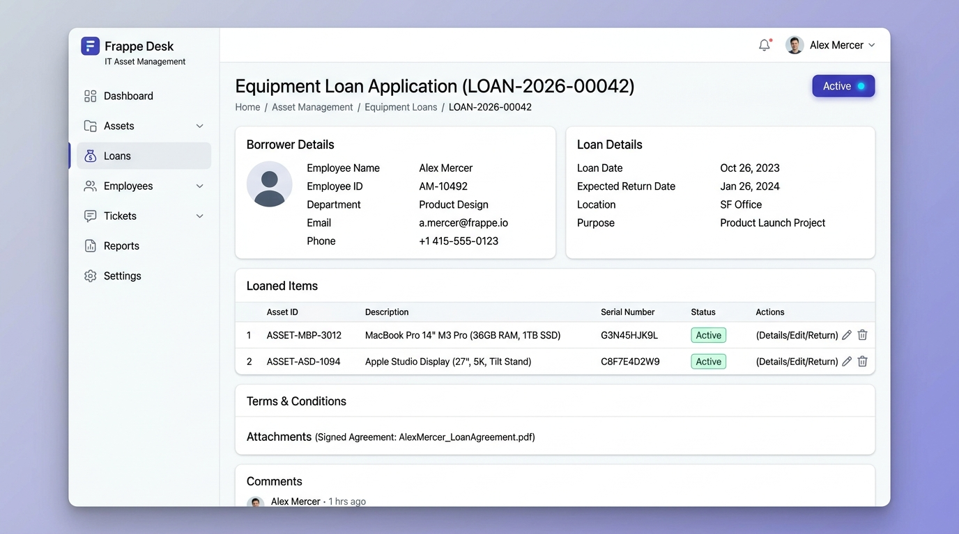
Figure 1: Verified Frappe Desk Equipment Loan Form (LOAN-2026-00042) showing active status and allocated item table.
Step 3.4: Processing Equipment Returns (Check-In)
When the employee brings back the equipment to the IT Helpdesk:
1. Open the active loan document.
2. Click the green 'Process Return' button in the top action bar.
3. The Process Equipment Return modal dialog opens with a hardware inspection checklist.
4. Confirm return date, check each operational box, select Condition Grade (Grade A / B / C), and enter inspector verification notes.
5. Click 'Confirm Return'. The document status transitions to Returned, and assets are released back to Available.

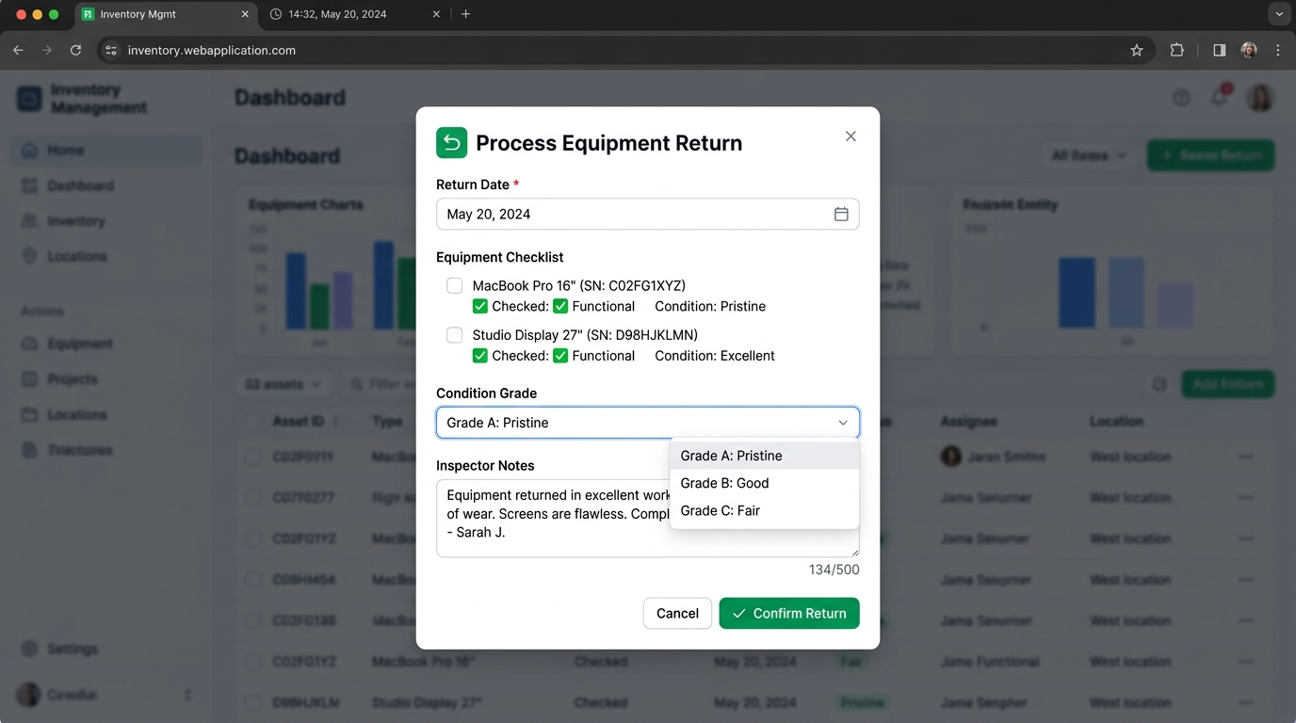
Figure 2: Verified Process Equipment Return inspection modal dialog with condition grade checklist and inspector notes.

4. Business Rule Failsafes & Error Resolution Guide
Error Message Encountered | Underlying Cause | Operator Corrective Action
Expected Return Date cannot be before Loan Date | User selected return date earlier than loan start date. | Set Expected Return Date to same day or later than Loan Effective Date.
Loan duration of X days exceeds maximum limit of 30 days | Policy SLA breach: loan request exceeds 30-day corporate cap. | Adjust return date within 30 days or obtain Department Head special waiver.
Asset AST-XXXX is currently 'Loaned Out' and unavailable | Asset is currently borrowed by another staff member. | Select a different asset marked Available in the inventory catalog.
Duplicate item AST-XXXX in loan table | The same hardware serial was added twice in child table. | Delete duplicate row using trash can icon.
Borrower EMP-XXXX has overdue equipment loan (LOAN-XXXX) | Borrower has an unreturned loan past due date. | STRICT LOCKOUT: Borrower must return overdue hardware before new loans can be issued.
At least one hardware item must be added to the loan | User attempted to submit a loan with zero items. | Click 'Add Row' and assign at least one hardware asset.

5. Automated REST API Reference for Technicians
For barcode scanning stations, automated locker check-ins, or IT ticketing systems:
Endpoint: POST /api/method/test_project.api.loan_api.process_return
Rate Limit: 30 requests / minute | Authentication: Token <api_key>:<api_secret>
{
"loan_id": "LOAN-2026-00042",
"actual_return_date": "2026-09-22",
"return_notes": "Returned via automated locker. All diagnostics passed."
}

